Dundalk Marine Terminal Evacuation Simulation Statement

To Maryland Port Administration

I. Simulation Areas
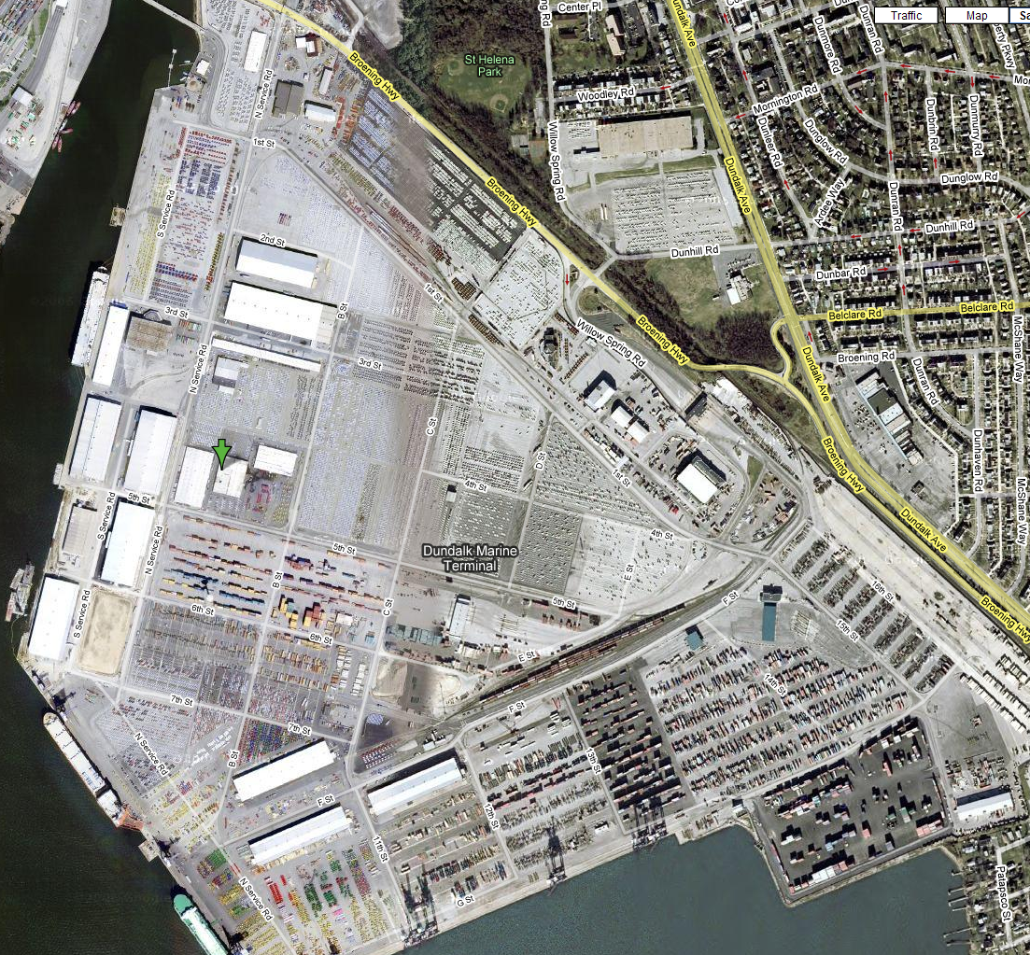
Figure-1 Google Map Satellite Image
Dundalk Marine Terminal

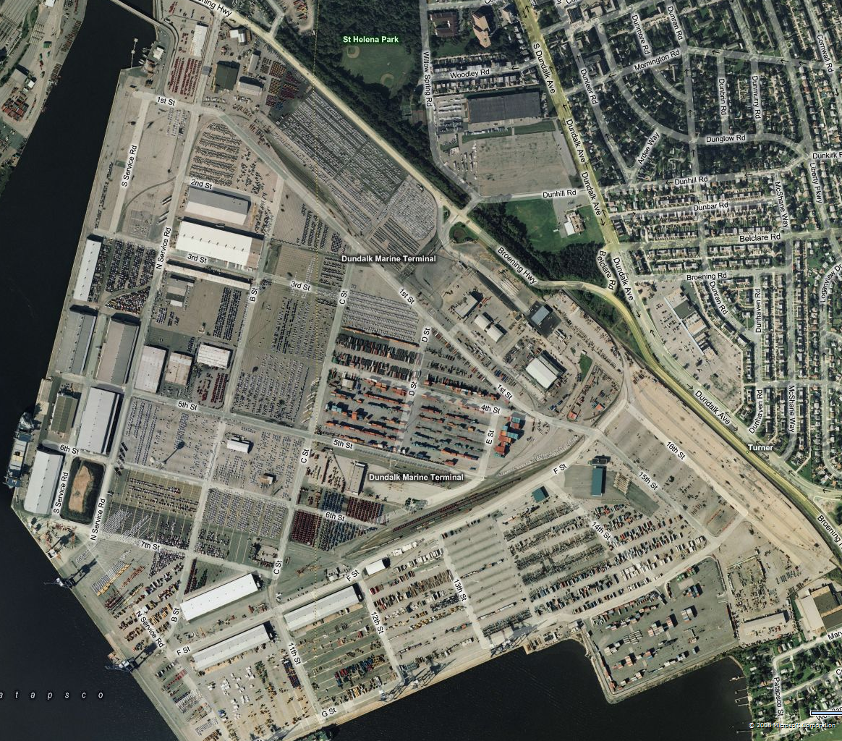
Figure-2 Maps Live Satellite Image
Dundalk Marine Terminal

II. Simulation Purpose
- To see impact of an evacuation and provide a better understanding of the additional necessary resources
- To evaluate the effectiveness of traffic network
- To test the efficacy of the gate facility exit process
- To test the ability to set up evacuation routes
- To provide a training tool to MPA staff
- To evaluate the impact of an evacuation on the connecting link (Broening Hwy) between the Dundalk Marine Terminal and the Seagirt Marine Terminal

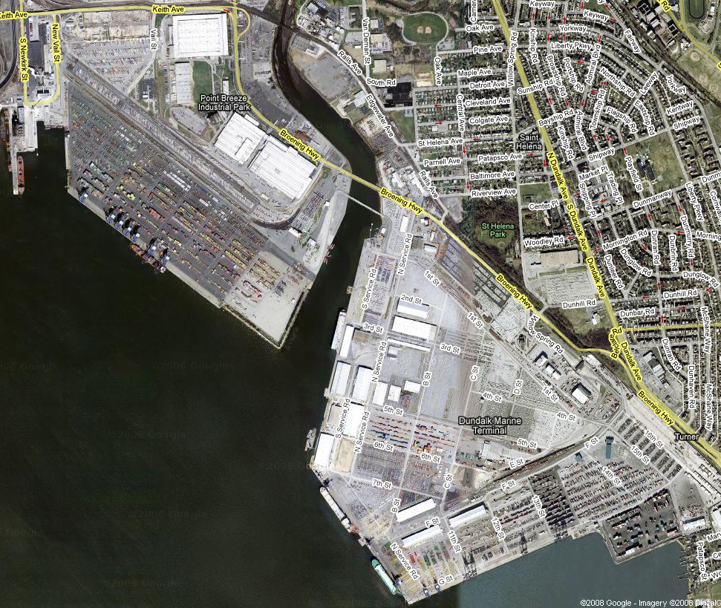
Figure-3 Connecting link between Dundalk Marine Terminal and Seagirt Marine Terminal

Seagirt Marine Terminal

Dundalk Marine Terminal

III. Simulation Items
Simulation Software  Simulation Items | Corsim | Vissim | Transmodeler
- Toll booths | × | × | √
- Security gates | × | × | ×
- Staging areas | × | √ | √
- Road sections closed or under construction | √ | √ | √
- Trucks evacuation | √ | √ | √
- Cars evacuation | √ | √ | √
- Shuttles evacuation | √ | √ | √
- Pedestrians evacuation  (longshoreman and other port personnel) | √ | √ | √
- Bottlenecks and choke-points visualizations | √ | √ | √
- Evacuation routes set up | × | √ | √
- Traffic situation on connecting link (Broening Hwy) between Dundalk Marine Terminal and the Seagirt Marine Terminal | √ | √ | √
- Evacuation 2D visualizations | √ | √ | √
- Evacuation 3D animation visualizations | × | √ | √

IV. Data needed
- Detailed traffic network map, including:
- Road names
- Number of lanes
- One-way or two-way
- Road sections closed or under construction
- Detailed terminal facilities layout map, including:
- Facility names
- Entrances and exits locations
- Traffic organization, including:
- Entering and leaving routes
- Signal control
- Initial traffic counts at each zone
- Evacuation demand data

V. Evacuation Model
- Input interface:
- Initial traffic counts
- Current entering and leaving routes
- Current signal controls
- Incident location and type
- Evacuation demand
- Output results:
- MOE
- External control plan
- Additional necessary resource

VI. Simulation cost
Simulation Software  Simulation Items | Corsim | Vissim | Transmodeler
Background image screen shot  Network building  Links (about 200) and nodes (about 90) | 30h | 15h | 15h
Demand input  Turning fraction setting  Lane alignment  Signal setting  Warning and error debugging | 3h | 1h | 1h
Toll booths | - | - | 1h
Security gates | - | - | -
Staging areas | 1h | 1h | 1h
Trucks evacuation | 1h | 1h | 1h
Cars evacuation | 1h | 1h | 1h
Shuttles evacuation | 1h | 2h | 2h
Pedestrians evacuation  (longshoreman and other port personnel) | 1h | 3h | 3h
Evacuation routes set up | - | 2h | 2h
Evacuation 2D visualizations | 1h | 1h | 1h
Evacuation 3D animation visualizations | - | 5h | 5h
Total | 38h | 32h | 33h

