Estimating the Max Capacity in Work Zone Area

Elham Sharifi
2008

1. Introduction
There are different definitions of capacity at a work zone area. For example “Hourly traffic volume under congested traffic conditions” or “Hourly traffic volume converted from the maximum-recorded five minute flow rate” or “Flow rate at which traffic behavior quickly changes from uncongested conditions to queued conditions” or “Flow just before a sharp speed drop”.
Our objective in this project is Estimating max capacity in work zone area and we have two capacity definition, “Max throughput” and “Flow rate at which traffic behavior quickly changes from uncongested conditions to queued conditions. (Traffic volume immediately before queue begins)”.

2. Survey Data Analysis
A Survey has been done in September 2007 in 6 days at work zone locations. They used 4 camcorders to videotape the traffic volumes. I used survey data on September 6th. The specifics of this survey data can be found below.
- Weather: Nice and calm
- Location: I-95 NB near exit 32
- Number of Total Lanes: 4
- Number of Closed Lanes: 2
- Position: 2 right lanes closure

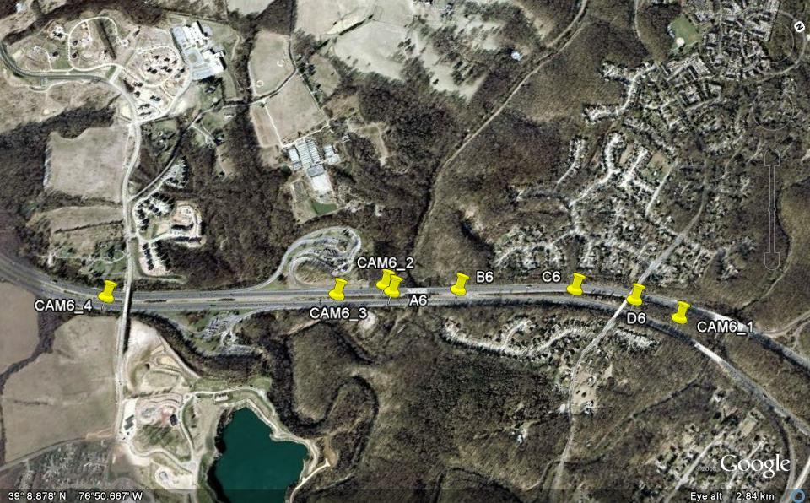
Figure(1). Location of Work Zone Area

The location of work zone area is shown in the Figure (1) and the geometry data is shown in the Table (1) and (2).

76 50.950 W
39 8.239 N
CAM6_4
Camcorder4
76 50.630 W
39 8.678 N
CAM6_3
Camcorder3
76 50.586 W
39 8.778 N
CAM6_2
Camcorder2
76 50.091 W
39 9.298 N
CAM6_1
Camcorder1
76 50.197 W
39 9.236 N
D6
2nd Lane Closure
76 50.306 W
39 9.135 N
C6
2nd Lane Taper Start
76 50.470 W
39 8.914 N
B6
1st Lane Closure
76 50.559 W
39 8.786 N
A6
1st Lane Taper Start
Longitude
Latitude
Symbol
Location
Table (1). Geometry Data

 | Length ( feet)
A6_B6 | 874
B6_C6 | 1548
C6_D6 | 790
D6_Camcorder1 | 627
A6_Camcorder2 | 102
A6_Camcorder3 | 725
A6_Camcorder4 | 3794
Table (2). Geometry Data

I used data of the camcorder 4 for input flow. We have the number of cars and trucks that pass the camcorder4 in each lane. I first calculated the 15min flow, then, I converted to one hour flow. (Table (3),(4) & (5))

Time | Lane 1 |  | Lane 2 |  | Lane 3 |  | Lane 4
Time | Car | Truck | Car | Truck | Car | Truck | Car | Truck
19:42:15-19:57:14 | 317 | 0 | 327 | 20 | 253 | 64 | 212 | 19
19:57:15-20:7:14 | 291 | 0 | 249 | 20 | 236 | 33 | 177 | 21
20:12:15-20:27:14 | 200 | 0 | 174 | 11 | 139 | 38 | 240 | 19
20:27:15-20:42:14 | 136 | 2 | 135 | 19 | 132 | 31 | 239 | 18
20:42:15-20:57:14 | 152 | 1 | 131 | 23 | 132 | 34 | 199 | 21
20:57:15-21:12:14 | 162 | 7 | 150 | 16 | 153 | 40 | 206 | 27
Table (3). 15min Input Flow

Time | Lane 1 |  | Lane 2 |  | Lane 3 |  | Lane 4
Time | Car | Truck | Car | Truck | Car | Truck | Car | Truck
19:42:15-19:57:14 | 1268 | 0 | 1308 | 80 | 1012 | 256 | 848 | 76
19:57:15-20:12:14 | 1164 | 0 | 996 | 80 | 944 | 132 | 708 | 84
20:12:15-20:27:14 | 800 | 0 | 696 | 44 | 556 | 152 | 960 | 76
20:27:15-20:42:14 | 544 | 8 | 540 | 76 | 528 | 124 | 956 | 72
20:42:15-20:57:14 | 608 | 4 | 524 | 92 | 528 | 136 | 796 | 84
20:57:15-21:12:14 | 648 | 28 | 600 | 64 | 612 | 160 | 824 | 108
Table (4). 15min Input Flow Converted to One Hour
Time | Total Cars  (Converted to  One Hour) | Total Vehicles  (Converted to  One Hour) | Percent  of  Trucks | Percent of  Vehicles in Lane1 | Percent of  Vehicles in Lane2 | Percent of  Vehicles in Lane3 | Percent of  Vehicles in Lane4
19:42:15-19:57:14 | 4436 | 4848 | 0.085 | 0.262 | 0.286 | 0.262 | 0.191
19:57:15-20:12:14 | 3812 | 4108 | 0.072 | 0.283 | 0.262 | 0.262 | 0.193
20:12:15-20:27:14 | 3012 | 3284 | 0.083 | 0.244 | 0.225 | 0.216 | 0.315
20:27:15-20:42:14 | 2568 | 2848 | 0.098 | 0.194 | 0.216 | 0.229 | 0.361
20:42:15-20:57:14 | 2456 | 2772 | 0.114 | 0.221 | 0.222 | 0.240 | 0.317
20:57:15-21:12:14 | 2684 | 3044 | 0.118 | 0.222 | 0.218 | 0.254 | 0.306
Table (5). Input Flow for the Model

3. Simulation of the Work Zone Area with CORSIM Software
I used the geometry data and input data from survey analysis to build the CORSIM model. The geometry of the model is shown in the Figure (2) and the model geometry data is shown in the Table (6).

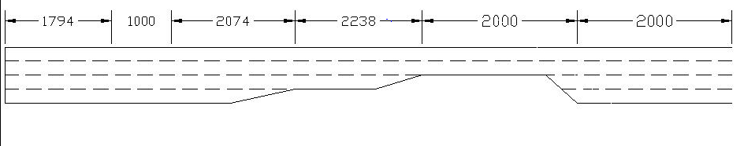
Figure (2). Geometry of the Model

Link# | 1 | 2 | 3 | 4 | 5 | 6
Length (ft) | 1794 | 1000 | 2074 | 2238 | 2000 | 2000
Number of Lanes | 4 | 4 | 4 | 3 | 2 | 4
Number of Dropped Lanes | 0 | 0 | 1 | 1 | 0 | 0
Number of Added Lanes | 0 | 0 | 0 | 0 | 2 | 0
Distance for Added or Dropped  Lanes from Upstream Node | - | - | 1874 | 2138 | 1980 | -
Table (6). Model Geometry Data
4. Calibrate the CORSIM model to get similar results as real case data
For getting better results for the base case, I changed the Vehicle Entry Headway from Normal Distribution to Uniform Distribution and Erlang distribution with a=1. The best results for the base case obtained by using Erlang distribution with a=1. Therefore, I used this distribution for vehicle headway in my modeling.
For calibrating the model, I changed 3 parameters one by one and checked the CORSIM outputs with the survey data. These three parameters are:
  - Free flow speed
  - Rubberneck factor
  - Car following factor

Also, I used the camcorder 1 and camcorder 3 data and also the queue length to calibrate the model.

The base case specifics and also the CORSIM output for camcorde1 and camcorder3 locations and queue length is shown in the Table (7), (8), (9) & (10).

Link# | 1 | 2 | 3 | 4 | 5 | 6
Free Flow Speed (mil/h) | 65 | 60 | 55 | 55 | 55 | 65
Rubberneck Factor(%) | 0 | 0 | 0 | 0 | 0 | 0
Car Following Factor(%) | 100 | 100 | 100 | 100 | 100 | 100
Table(7). Base Case Specifics

Location(Camcorder1)
Time | Number of Vehicles |  | Error Percent
Time | Corsim Simulation | Survey Data | Error Percent
20:12-20:27 | 917 | 864 | 6.1
20:27-20:42 | 889 | 842 | 5.6
20:42-20:57 | 881 | 838 | 5.1
Table(8). Camcorder1 Location Comparison for the Base Case

Location(Camcorder3)
Time | Number of Vehicles |  | Error Percent
Time | Corsim Simulation | Survey Data | Error Percent
19:42-19:57 | 1154 | 1171 | -1.5
19:57-20:12 | 832 | 938 | -11.3
20:12-20:27 | 742 | 741 | 0.1
20:27-20:42 | 735 | 746 | -1.5
Table(9). Camcorder3 Location Comparison for the Base Case

Queue length from the transition start point
Time | Corsim Simulation  (feet) | Survey Data (feet) | Error Percent
20:17 | 2490 | 7006 | -64.5
Table(10). Queue Length Comparison for the Base Case

For the best case, Camcorder1 location data is acceptable but camcorder3 location data has one error more than 11 percent. The most important problem here is the queue length. So, I changed the mentioned parameters one by one. First I changed the free flow speed. The changing in output in camcorde3 location when the free flow speed is changed can be seen in the Table (11).

Location Camcorder3
Time | Number of Vehicles (speed=55 , change in link 3 rubberneck)
Time | Survey  Data | r.n.=0 | r.n.=10 |  | r.n.=20 |  | r.n.=30 |  | r.n.=40 |  | r.n.=50 |  | r.n.=60 | r.n.=70
19:42-19:57 | 1171 | 1154 | 1171 |  | 1073 |  | 1011 |  | 875 |  | 821 |  | Veh.  backed up | Veh.  Backed  up
19:57-20:12 | 938 | 832 | 850 |  | 853 |  | 896 |  | 849 |  | 778 |  | Veh.  backed up | Veh.  Backed  up
20:12-20:27 | 741 | 742 | 778 |  | 811 |  | 861 |  | 851 |  | 777 |  | Veh.  backed up | Veh.  Backed  up
20:27-20:42 | 746 | 735 | 698 |  | 711 |  | 716 |  | 788 |  | 760 |  | Veh.  backed up | Veh.  Backed  up
 |  | Error percentage
 |  | -1.5 | 0.0 | -8.4 |  | -13.7 |  | -25.3 |  | -29.9
 |  | -11.3 | -9.4 | -9.1 |  | -4.5 |  | -9.5 |  | -17.1
 |  | 0.1 | 5.0 | 9.4 |  | 16.2 |  | 14.8 |  | 4.9
 |  | -1.5 | -6.4 | -4.7 |  | -4.0 |  | 5.6 |  | 1.9
Table (11). Camcorder3 Location Comparison for different Free Flow Speed

In the Table (11) it can be seen that the best results is for Free Flow Speed = 55 mile/hour.
For the camcorder1 location the results for all of these free flow speeds are good but the queue length is still the most important problem and it is much different from the real case data. So, the best free flow speed is 55 mile/hour and I chose this one.
Then I changed the Rubberneck factor in link 3, 4 and 5. The changing in rubberneck factor in link 4 & 5 did not give us good results. As you can see in the Table (12) rubberneck factor = 10% in link 3 gave the best results, so I chose this rubberneck factor for link3 but again the big problem was the queue length.

Location(Camcorder3)
Time | Number of Vehicles (speed=55 , change in link 3 rubberneck)
Time | Survey  Data | r.n.=0 | r.n.=10 | r.n.=20 |  | r.n.=30 | r.n.=40 |  | r.n.=50 | r.n.=60 | r.n.=70
19:42-19:57 | 1171 | 1154 | 1171 | 1073 |  | 1011 | 875 |  | 821 | Veh.  backed up | Veh.  Backed  up
19:57-20:12 | 938 | 832 | 850 | 853 |  | 896 | 849 |  | 778 | Veh.  backed up
20:12-20:27 | 741 | 742 | 778 | 811 |  | 861 | 851 |  | 777 | Veh.  backed up
20:27-20:42 | 746 | 735 | 698 | 711 |  | 716 | 788 |  | 760 | Veh.  backed up
 |  | Error percentage
 |  | -1.5 | 0.0 |  | -8.4 | -13.7 |  | -25.3 | -29.9
 |  | -11.3 | -9.4 |  | -9.1 | -4.5 |  | -9.5 | -17.1
 |  | 0.1 | 5.0 |  | 9.4 | 16.2 |  | 14.8 | 4.9
 |  | -1.5 | -6.4 |  | -4.7 | -4.0 |  | 5.6 | 1.9
Table (12). Camcorder3 Location Comparison for Different Rubberneck Factor in Link3

Then I used this rubberneck factor for link3 and again changed the free flow speed to see which one is better when the rubberneck factor in link 3 is 10%. The results are shown in the Table (13) & (14).

Location(Camcorder3)
Time | Number of Vehicles ( in link 3 rubberneck=10%)
Time | Survey  Data | Speed=65 | Speed=55 | error | Speed=45 | error | Speed=35
19:42-19:57 | 1171 | 1040 | 1171 | 0.0 | 1081 | -7.7 | 1064
19:57-20:12 | 938 | 781 | 850 | -9.4 | 934 | -0.4 | 850
20:12-20:27 | 741 | 785 | 778 | 5.0 | 776 | 4.7 | 812
20:27-20:42 | 746 | 739 | 698 | -6.4 | 719 | -3.6 | 717
Table (13). Camcorder3 Location Comparison for Different Free Flow Speeds When the Rubberneck Factor in Link3 is 10%

Location(Camcorder1)
Time | Number of Vehicles ( in link 3 rubberneck=10%)
Time | Survey  Data | Speed=65 | Speed=55 | error | Speed=45 | error | Speed=35
20:12-20:27 | 864 | 925 | 892 | 3.2 | 932 | 7.9 | 959
20:27-20:42 | 842 | 897 | 900 | 6.9 | 898 | 6.7 | 909
20:42-20:57 | 838 | 880 | 836 | -0.2 | 738 | -11.9 | 749
Table (14). Camcorder1 Location Comparison for Different Free Flow Speeds When the Rubberneck Factor in Link3 is 10%

It is seen in the Table (13) & (14) that the speed =45 & 55 gives good results in camcorder3 location but in camcorder 1 location the 45 mile/hour speed has one error about 12%. Therefore, I chose the 55 mile/hour for free flow speed. Again the queue length was the big problem.
Then, I changed the Car Following Factor in link 3, 4 & 5. Changing this factor in link 4 & 5 did not give good results, so I only bring the results for changing this factor in link3. (see the Table (15) & (16))

Location(Camcorder3)
Time | Number of Vehicles ( speed=55 and in link 3 rubberneck=10%)
Time | Survey  Data | C.F.F=120 | error | C.F.F=140 | error | C.F.F=150 | error | C.F.F=160 | error
19:42-19:57 | 1171 | 1051 | -10.2 | 1005 | -14.2 | 1047 | -10.6 | 968 | -17.3
19:57-20:12 | 938 | 834 | -11.1 | 927 | -1.2 | 931 | -0.7 | 922 | -1.7
20:12-20:27 | 741 | 835 | 12.7 | 937 | 26.5 | 927 | 25.1 | 892 | 20.4
20:27-20:42 | 746 | 768 | 2.9 | 747 | 0.1 | 753 | 0.9 | 839 | 12.5
Queue(feet) | 7006 | 5706 | -18.6 | 5806 | -17.1 | 5756 | -17.8 | 6279 | -10.4
Table (15). Camcorder3 Location and Queue Length Comparison for Different Car Following Factors

Location(Camcorder1)
Time | Number of Vehicles ( speed=55 and in link 3rubberneck=10%)
Time | Survey  Data | C.F.F=120 | error | C.F.F=140 | error | C.F.F=150 | error | C.F.F=160 | error
20:12-20:27 | 864 | 931 | 7.8 | 983 | 13.8 | 973 | 12.6 | 921 | 6.6
20:27-20:42 | 842 | 874 | 3.8 | 917 | 8.9 | 914 | 8.6 | 947 | 12.5
20:42-20:57 | 838 | 878 | 4.8 | 695 | -17.1 | 694 | -17.2 | 797 | -4.9
Table (16). Camcorder1 Location Comparison for Different Car Following Factors

In the Table (15) & (16), it is seen that the best queue length is for C.F.F =160 in link3, but the camcorder1&3 location data are not in acceptable range of error. Because the queue length in this situation is the best one I could find so far, I decided to choose this C.F.F for link 3 and change the rubberneck factor in the links to get good results for the camcorder1 & 3 location data.

After changing the rubberneck factor in link 3, 4 & 5, I also checked the combination of them. In addition, I used the changing rubberneck factor by time in a link. The situation of the best results is shown in the Table (17).

Link# | 1 | 2 | 3 |  | 4 | 5 | 6
Free Flow Speed (mile/h) | 65 | 60 | 55 |  | 55 | 55 | 65
Rubberneck Factor(%) | 0 | 0 | 10 | 50 | 2 | 0 | 0
Time of Onset(sec) |  |  | 300 | 900 | 1500
Car Following Factor(%) | 100 | 100 | 160 |  | 100 | 100 | 100
Table (17). The Model Parameters for the Best Results

It is seen in the Table (17) that the Free Flow Speed is the same as the base case and the Car Following Factor is 160 for link3 and 100 for other links. The Rubberneck Factor is zero in all links at the beginning but after 300 sec (5-min) it changes to 10% in link 3 and after 900 sec (15-min) another 50% Rubberneck Factor is added to link3. Furthermore, after 1500 sec (25-min) the Rubberneck Factor in link4 becomes 2%.
The results of this situation are shown in the Table (18) & (19).

Location(Camcorder3)
Time | Number of Vehicles for the Best Situation
Time | Survey Data | CORSIM | error
19:42-19:57 | 1171 | 1087 | -7.2
19:57-20:12 | 938 | 847 | -9.7
20:12-20:27 | 741 | 766 | 3.4
20:27-20:42 | 746 | 739 | -0.9
Queue Length (feet) | 7006 | 6119 | -12.7
Table (18). Camcorder3 Location and Queue Length Comparison for the Best Situation

Location(Camcorder1)
Time | Number of Vehicles for the Best Situation
Time | Survey Data | CORSIM | error
20:12-20:27 | 864 | 790 | -8.6
20:27-20:42 | 842 | 775 | -8.0
20:42-20:57 | 838 | 787 | -6.1
Table (19). Camcorder1 Location Comparison for the Best Situation

In the Table (18) & (19), it is seen that the results have acceptable errors.
5. Estimating the Max Capacity
I used 9% truck percentage (the same as survey data) and 25% of input flow in each lane and changed the input flow from 6400 veh/h to 3200 veh/h to find the max throughput. Also, it could be seen that in which flow the queue disappeared. I ran the CORSIM with 6 random seed numbers for each input flow and got the mean throughput of these data. Then, I calculated the standard deviation for throughputs and by dividing the standard deviation of throughputs by mean throughput, it can be seen that this amount for all input flows is less than 7%, so the results are acceptable. The mean throughput and queue condition for different input flows are shown in the Table(20).
 | Location(Camcorder1) | Location(Camcorder3)
Input (vehicle/hour) | Number of Throughput  Vehicle/hour/lane | Number of Throughput  Vehicle/hour/lane | Queue Condition
6400 | 1569 | 775 | Queue
6000 | 1610 | 795 | Queue
5600 | 1618 | 801 | Queue
5200 | 1665 | 819 | Queue
4800 | 1615 | 799 | Queue
4400 | 1606 | 805 | Queue
4000 | 1579 | 797 | Queue
3800 | 1598 | 811 | Queue
3700 | 1642 | 840 | Queue
3600 | 1784 | 899 | No Queue
3500 | 1750 | 874 | No Queue
3400 | 1700 | 849 | No Queue
3200 | 1599 | 799 | No Queue
Table(20). Mean Throughput and Queue Condition for Different Input Flows

It can be seen in the Table (20) that the max throughput in both locations (camcorder1 & 3 locations) takes place at the same input flow (3600 veh/hour). Also, this flow is exactly when the queue disappears.
The standard deviation of throughputs divided by mean throughput for different input flows is shown in the Table (21). All of the numbers are below 7 % and it shows that our results are good.

 | Location(Camcorder1) | Location(Camcorder3)
Input (vehicle/hour) | Standard Deviation/Mean % | Standard Deviation/Mean %
6400 | 1.3 | 1.7
6000 | 4.8 | 4.7
5600 | 3.2 | 3.3
5200 | 6.4 | 6.5
4800 | 2.3 | 2.8
4400 | 2.4 | 2.6
4000 | 1.4 | 1.6
3800 | 2.0 | 2.6
3700 | 3.0 | 3.5
3600 | 2.0 | 0.4
3500 | 0.1 | 0.1
3400 | 0.1 | 0.1
3200 | 0.1 | 0.1
Table(21). Standard Deviation/Mean of Throughputs for Different Input Flows

The throughputs in both locations are drawn versus input flow in Figure(3).
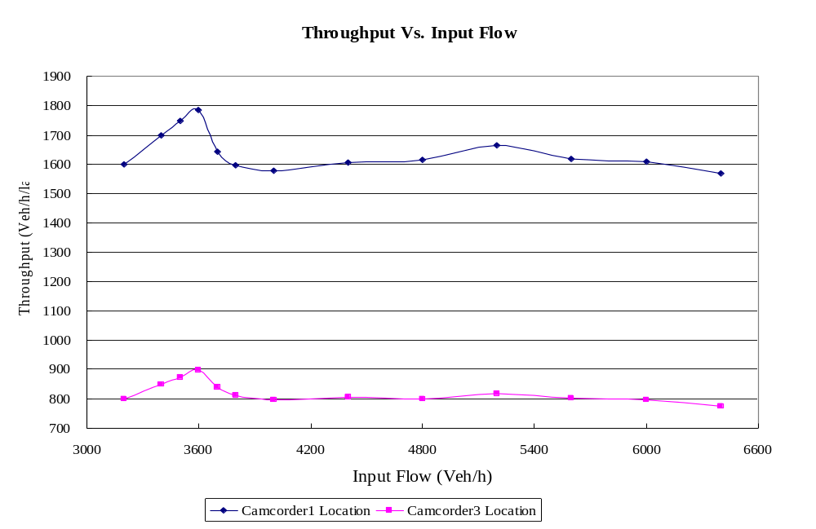

Figure(3). Throughput in Both Locations versus Input Flow

6. Estimating the Max Throughput for Different Truck Percentages
We changed the truck percentage and with 3 random seed numbers we calculated the max throughput. The results can be seen in the Table(22)_(27).

5% Truck Percentage
 | Location(Camcorder1) | Location(Camcorder3)
Input (vehicle/hour) | Number of Throughput  (Vehicle/hour/lane) | Number of Throughput  (Vehicle/hour/lane)
6000 | 1623 | 802
5600 | 1734 | 855
5200 | 1754 | 870
4800 | 1726 | 859
4400 | 1731 | 864
4000 | 1631 | 831
3800 | 1852 | 938
3700 | 1790 | 905
3600 | 1800 | 899
3400 | 1700 | 849
Table(22). Throughputs in Camcorder1 & 3 Locations versus Different Input Flows for 5% Truck Percentage

10% Truck Percentage
 | Location(Camcorder1) | Location(Camcorder3)
Input (vehicle/hour) | Number of Throughput  (Vehicle/hour/lane) | Number of Throughput  (Vehicle/hour/lane)
6000 | 1602 | 797
5600 | 1601 | 789
5200 | 1600 | 788
4800 | 1590 | 791
4400 | 1669 | 838
4000 | 1590 | 801
3800 | 1577 | 801
3700 | 1630 | 834
3600 | 1795 | 900
3500 | 1750 | 874
3400 | 1698 | 849
3200 | 1598 | 800
Table(23). Throughputs in Camcorder1 & 3 Locations versus Different Input Flows for 10% Truck Percentage
20% Truck Percentage
 | Location(Camcorder1) | Location(Camcorder3)
Input (vehicle/hour) | Number of Throughput  (Vehicle/hour/lane) | Number of Throughput  (Vehicle/hour/lane)
6000 | 1496 | 741
5600 | 1475 | 729
5200 | 1487 | 733
4800 | 1509 | 745
4400 | 1499 | 745
4000 | 1487 | 745
3800 | 1480 | 745
3700 | 1489 | 750
3600 | 1495 | 755
3500 | 1501 | 765
3400 | 1627 | 819
3300 | 1650 | 824
3200 | 1599 | 799
Table(24). Throughputs in Camcorder1 & 3 Locations versus Different Input Flows for 20% Truck Percentage

30% Truck Percentage
 | Location(Camcorder1) | Location(Camcorder3)
Input (vehicle/hour) | Number of Throughput  (Vehicle/hour/lane) | Number of Throughput  (Vehicle/hour/lane)
4400 | 1395 | 691
4000 | 1389 | 694
3600 | 1385 | 698
3400 | 1400 | 710
3300 | 1413 | 716
3200 | 1515 | 776
3100 | 1549 | 775
3000 | 1498 | 750
Table(25). Throughputs in Camcorder1 & 3 Locations versus Different Input Flows for 30% Truck Percentage

40% Truck Percentage
 | Location(Camcorder1) | Location(Camcorder3)
Input (vehicle/hour) | Number of Throughput  (Vehicle/hour/lane) | Number of Throughput  (Vehicle/hour/lane)
3600 | 1310 | 659
3200 | 1316 | 668
3100 | 1378 | 706
3000 | 1465 | 743
2900 | 1448 | 724
2800 | 1403 | 699
Table(26). Throughputs in Camcorder1 & 3 Locations versus Different Input Flows for 40% Truck Percentage

50% Truck Percentage
 | Location(Camcorder1) | Location(Camcorder3)
Input (vehicle/hour) | Number of Throughput  (Vehicle/hour/lane) | Number of Throughput  (Vehicle/hour/lane)
3600 | 1259 | 632
3200 | 1254 | 637
3100 | 1268 | 646
3000 | 1251 | 637
2900 | 1358 | 692
2800 | 1331 | 682
2750 | 1374 | 688
2700 | 1351 | 674
2600 | 1300 | 649
Table(27). Throughputs in Camcorder1 & 3 Locations versus Different Input Flows for 50% Truck Percentage

The graph of the throughputs in camcorder1 location is shown in Figure (4) and the graph for camcorder3 location is shown in Figure (5).

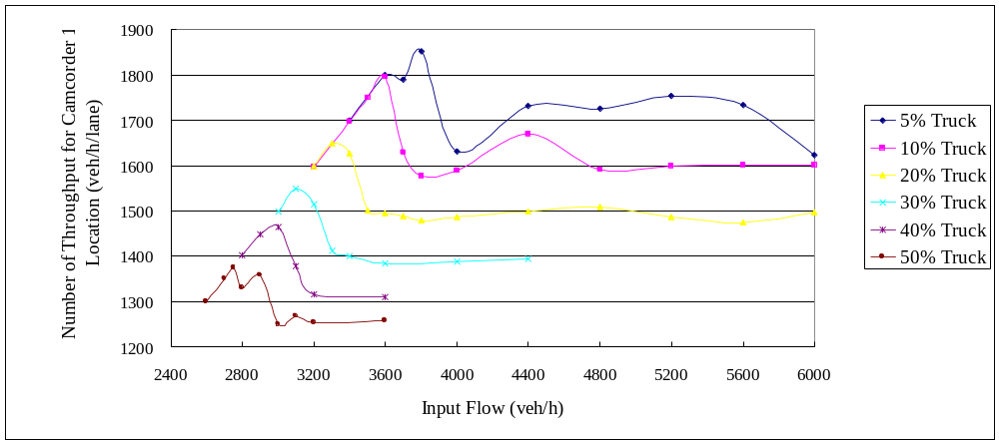
Figure(4). Throughput in Camcorder1 Location versus Input Flow for Different Truck Percentages

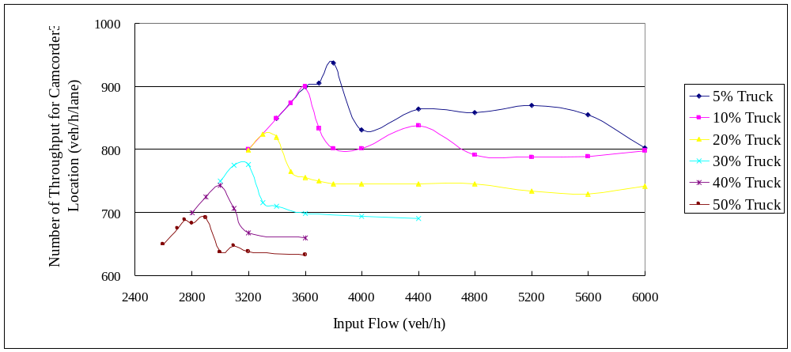
Figure(5). Throughput in Camcorder3 Location versus Input Flow for Different Truck Percentages

Max throughput in Camcorder 3 Location for different truck percentages are shown in Table(28) and the graph is shown in Figure(6).

Percentage of Trucks | Max Number of Throughput in Camcorder 3 location  (Vehicle/hour/lane)
5% Truck | 938
10% Truck | 900
20% Truck | 824
30% Truck | 776
40% Truck | 743
50% Truck | 692
Table (28). Max Throughput in Camcorder3 Location for Different Truck Percentages

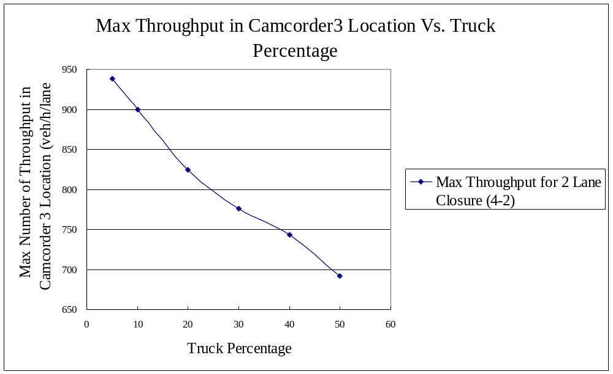
Figure(6). Max Throughput in Camcorder3 Location for Different Truck Percentages (for 2 Lane Closure)

7. Estimating the Max Throughput for Different Truck Percentages for 1 Lane Closure (4-3 lane)
We changed the geometry of work zone to have only one lane closure and changed the truck percentage and with 3 random seed numbers we calculated the max throughput. The results can be seen in the Table(29)_(34).

5% Truck Percentage
 | Location(Camcorder1) | Location(Camcorder3)
Input (vehicle/hour) | Number of Throughput  (Vehicle/hour/lane) | Number of Throughput  (Vehicle/hour/lane)
6000 | 1269 | 923
5600 | 1269 | 917
5200 | 1266 | 914
4800 | 1273 | 928
4400 | 1280 | 943
4200 | 1283 | 950
4100 | 1334 | 996
4080 | 1345 | 1011
4000 | 1333 | 998
3800 | 1267 | 949
3600 | 1198 | 899
Table(29). Throughputs in Camcorder1 & 3 Locations versus Different Input Flows for 5% Truck Percentage

10% Truck Percentage
 | Location(Camcorder1) | Location(Camcorder3)
Input (vehicle/hour) | Number of Throughput  (Vehicle/hour/lane) | Number of Throughput  (Vehicle/hour/lane)
6000 | 1242 | 897
5600 | 1243 | 903
5200 | 1246 | 905
4800 | 1242 | 906
4400 | 1246 | 916
4200 | 1249 | 924
4100 | 1255 | 929
4000 | 1333 | 999
3800 | 1267 | 949
3600 | 1200 | 898
3200 | 1066 | 800
Table(30). Throughputs in Camcorder1 & 3 Locations versus Different Input Flows for 10% Truck Percentage

20% Truck Percentage
 | Location(Camcorder1) | Location(Camcorder3)
Input (vehicle/hour) | Number of Throughput  (Vehicle/hour/lane) | Number of Throughput  (Vehicle/hour/lane)
6000 | 1206 | 882
5600 | 1220 | 895
5200 | 1205 | 879
4800 | 1216 | 891
4400 | 1209 | 886
4000 | 1223 | 907
3900 | 1252 | 944
3800 | 1264 | 950
3700 | 1231 | 924
3600 | 1199 | 899
3200 | 1067 | 800
Table(31). Throughputs in Camcorder1 & 3 Locations versus Different Input Flows for 20% Truck Percentage

30% Truck Percentage
 | Location(Camcorder1) | Location(Camcorder3)
Input (vehicle/hour) | Number of Throughput  (Vehicle/hour/lane) | Number of Throughput  (Vehicle/hour/lane)
4400 | 1186 | 869
4000 | 1186 | 879
3900 | 1189 | 883
3800 | 1200 | 899
3700 | 1215 | 912
3600 | 1199 | 900
3200 | 1068 | 799
Table(32). Throughputs in Camcorder1 & 3 Locations versus Different Input Flows for 30% Truck Percentage

40% Truck Percentage
 | Location(Camcorder1) | Location(Camcorder3)
Input (vehicle/hour) | Number of Throughput  (Vehicle/hour/lane) | Number of Throughput  (Vehicle/hour/lane)
6000 | 1165 | 861
4400 | 1159 | 853
4000 | 1159 | 860
3800 | 1166 | 867
3700 | 1165 | 871
3600 | 1173 | 887
3400 | 1134 | 849
3200 | 1065 | 799
Table(33). Throughputs in Camcorder1 & 3 Locations versus Different Input Flows for 40% Truck Percentage

50% Truck Percentage
 | Location(Camcorder1) | Location(Camcorder3)
Input (vehicle/hour) | Number of Throughput  (Vehicle/hour/lane) | Number of Throughput  (Vehicle/hour/lane)
4400 | 1138 | 843
4000 | 1148 | 852
3700 | 1146 | 856
3600 | 1142 | 857
3500 | 1160 | 874
3400 | 1131 | 849
3200 | 1064 | 800
Table(34). Throughputs in Camcorder1 & 3 Locations versus Different Input Flows for 50% Truck Percentage

The graph of the throughputs in camcorder1 location is shown in Figure (7) and the graph for camcorder3 location is shown in Figure (8).

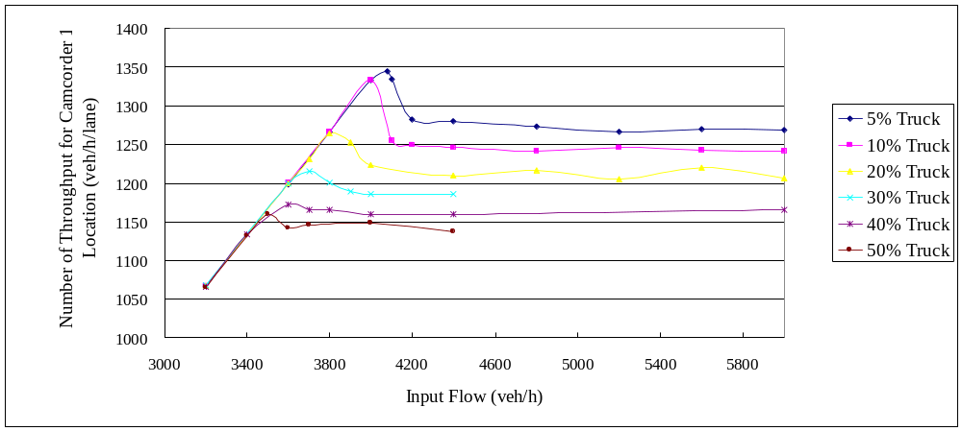
Figure(7). Throughput in Camcorder1 Location versus Input Flow for Different Truck Percentages (for 1 Lane Closure)

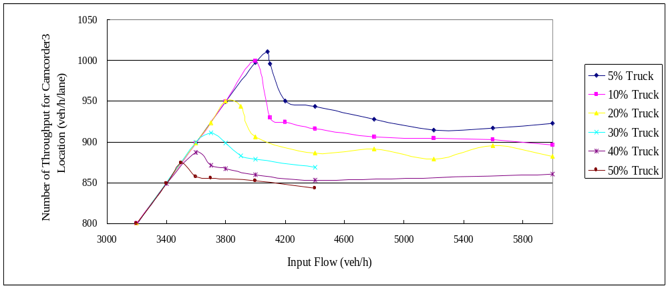
Figure(8). Throughput in Camcorder3 Location versus Input Flow for Different Truck Percentages (for 1 Lane Closure)

Max throughput in Camcorder 3 Location for different truck percentages are shown in Table(35) and the graph is shown in Figure(9).

Percentage of Trucks | Max Number of Throughput in Camcorder 3 location  (Vehicle/hour/lane)
5% Truck | 1011
10% Truck | 999
20% Truck | 950
30% Truck | 912
40% Truck | 887
50% Truck | 874
Table(35). Max Throughput in Camcorder3 Location for Different Truck Percentages (for 1Lane Closure)

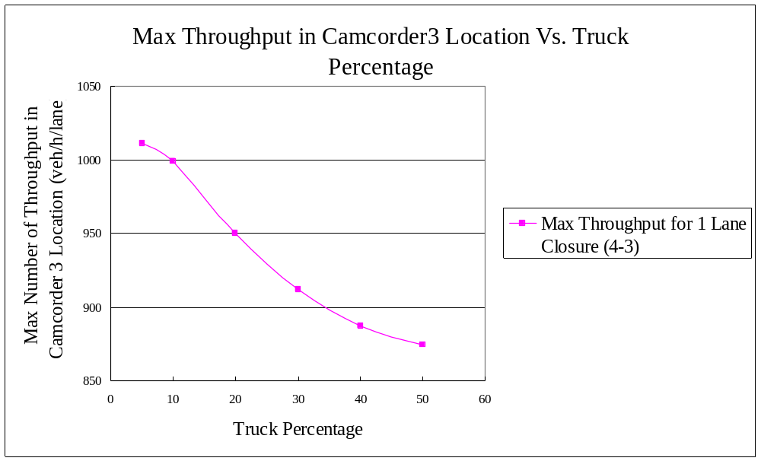
Figure(9). Max Throughput in Camcorder3 Location for Different Truck Percentages (for 1 Lane Closure)

The comparison of max throughput in camcorder3 location for 1- lane closure and 2- lane closure for different truck percentages can be seen in Table(36) and Figure(10).

Percentage of Trucks | Max Number of Throughput in Camcorder 3 location  (Vehicle/hour/lane)
Percentage of Trucks | 2 lane closure(4-2) | 1 lane closure(4-3)
5% Truck | 938 | 1011
10% Truck | 900 | 999
20% Truck | 824 | 950
30% Truck | 776 | 912
40% Truck | 743 | 887
50% Truck | 692 | 874
Table(36). Comparison of Max Throughput in Camcorder3 Location for Different Truck Percentages for 1Lane & 2Lane Closure
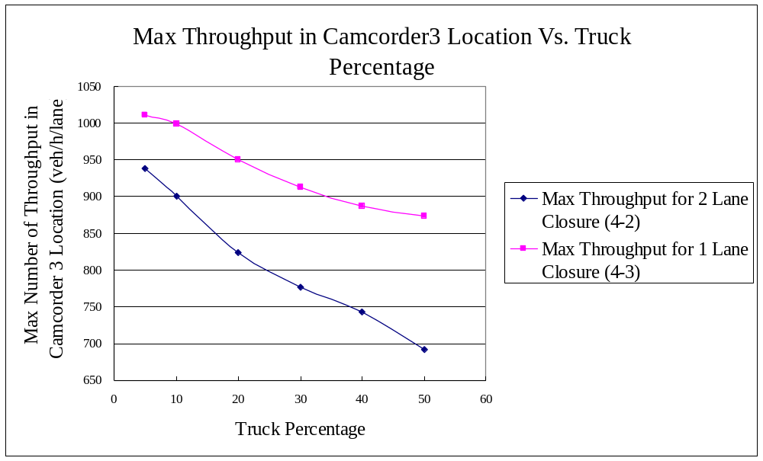
Figure(10). Comparison of Max Throughput in Camcorder3 Location for Different Truck Percentages for 1 Lane & 2 Lane Closure

8. Conclusion
It can be seen in the results that max throughput in both locations takes place with the same input flow and also the max throughput happens exactly before queue starts. As it was obvious，by increasing the truck percentage the max throughput decreases.
In addition, the max throughput in camcorder3 location is higher when only one lane is closed in comparison with 2 lane closure throughput.
Decreasing in camcorder1 location throughput for 1 lane closure in comparison with 2 lane closure is because of limitation in camcorder3 location throughput (for example for 5% truck percentage the max throughput in camcorder3 location is 1011 veh/h/lane and there are 4lanes so the total numbers of throughput is 4044. These vehicles should pass through 3 lanes ,therefore the max throughput in camcorder1 location is 1345).

References

- R.F. Benekohal, A.Z. Kaja-Mohideen and M.V. Chitturi (2004) “Methodology for Estimating Operating Speed and Capacity in Work Zones", Transportation Research Record 1883, pp. 103-111.

- T. Schnell, J.S. Mohror and F. Aktan “Evaluation of traffic Flow Analysis Tools Applied to Work Zones Based on Flow Data Collected in the Field", Transportation Research Record 1811, pp.57-66.

- T.H. Maze, S.D. Schrock and A. Kamyab (2000) “Capacity of Freeway Work Zone Lane Closures ", Mid-Continent Transportation Symposium 2000 Proceedings, pp.178-183

- Sarasua, Davis, Chowdhury and Ogle (2006) “Development of a Methodology to Estimate the Interstate Highway Capacity for Short-Term Work Zone Lane Closures ", TRB 2006 Annual Meeting

- A. Al-Kaisy and F. Hall (2003) “ Guidelines for Estimating Capacity at Freeway Reconstruction Zones", Journal of Transportation Engineering © ASCE , pp.572-577

- T. Kim, D.J. Lovell and J. Paracha (2001) “ A New Methodology to Estimates Capacity for Freeway Work Zones”, Transportation Research Board Annual Meeting 2001

