Dynamic Late Merge Control at Highway Work Zones: Evaluation, Observations, and Suggestions

By

Kyeong-Pyo Kang (Corresponding author)

Dept. of Civil Engineering, University of Maryland

1173 Glenn L. Martin Hall

College Park, MD 20742

Tel: 301-405-6959, Fax: 301-405-2585, kpkang@wam.umd.edu

Gang-Len Chang
Dept. of Civil Engineering, University of Maryland

1173 Glenn L. Martin Hall

College Park, MD 20742
Tel: 301-405-1953, Fax: 301-405-2585, gang@Glue.umd.edu

and

Jawad Paracha
Office of Traffic & Safety, MD State Highway Administration
7491 Connelley Drive
Hanover, Maryland 21076
Tel: 410-787-5891, Fax: 410-582-9469, JParacha@sha.state.md.us

* Total number of words: 7,407 = 4,157 (main text) + 3,250 (7 tables and 6 figures)

ABSTRACT

The purpose of this study is to present the evaluation result of a dynamic late merge (DLM) system for highway work zone operations, experimented by Maryland State Highway Administration (MSHA) and International Road Dynamics (IRD) Inc. The evaluation is focused mainly on the operational efficiency such as the input-output analysis, work zone throughput, volume distribution, and the resulting queue length. The evaluation results reveal that a properly deployed DLM system can indeed outperform the conventional merge control with respect to the total work zone throughputs. Such a system, however, may result in excessive traffic conflicts if not properly integrated with existing static warning signs for work zone operations. Some suggestions and guidelines developed from the field observations and analysis results for potential improvement of the DLM performance are also presented in this paper.

BACKGROUND
To effectively contend with the delay and traffic safety issues in highway work zones has long been one of the priority tasks of most state highway agencies. Over the past several decades, traffic researchers and engineers have proposed a variety of merge control methods to improve the work zone safety and efficiency. Table 1 summarizes some of those control strategies (1 - 5) that have been implemented or tested in practice, including the conventional merge, static early and late merge, and dynamic early merge controls.
However, the performance of those control strategies with respect to traffic efficiency and safety remains to be improved, especially in contending with highly fluctuated traffic demand. For example, the conventional merge control works well only when the traffic demand doesn’t exceed the work zone capacity. The static and dynamic early merge (e.g., Indiana lane merge, 4, 5) controls can contribute to smooth merges and reduced conflicts only under uncongested traffic conditions. Although the static late merge control (e.g., PennDOT merge, 1 - 3) can increase the work zone throughputs and decrease the travel time under congested traffic conditions, it may incur right-of-way conflict and potential for accident around the merging taper.
In brief, the early merge control seems to perform well regarding traffic safety only under free or moderate traffic conditions, while the late merge control can improve the operational efficiency mainly under congested traffic conditions. To take advantage of both control strategies, traffic researchers have recently proposed a dynamic late merge (DLM) control method (6) that intends to integrate the strengths of all existing merging controls, and offers the flexibility to effectively respond to demand variations.
The basic concept of the DLM control strategy is that it can respond to real-time traffic conditions detected by a set of sensors (e.g., loop detector or microwave sensor) in the upstream segment of the lane-closed work zone, and then regulate the merging actions of drivers (e.g., merging times and locations) based on the pre-determined control threshold. For example, when the detected traffic conditions exceed the specified threshold (e.g., speed, volume, or occupancy), the DLM control will function similarly to the static late merge control and display their merging messages at several upstream locations. Without activation of its control function during the uncongested period, the DLM will essentially perform as a conventional (or static early) merge control.
Despite the potential effectiveness of the DLM control, its performance with respect to both operational efficiency (e.g., throughput) and traffic safety (e.g., merging conflict) has not been extensively evaluated with field deployments. This paper presents the evaluation results of a DLM demonstration project, deployed by Maryland State Highway Administration (MSHA) and International Road Dynamics (IRD), including recommendations for future improvements.
This paper is organized as follows. The deployed DLM system is briefly described in the next section, followed by a presentation of the data collection plan in Section 3. The evaluation results based on field and simulated data analyses are presented in Section 4. Based on both field observations and evaluation results, this study has identified some critical issues associated with the DLM system performance in Section 5. Conclusions and further research work are summarized in the last section.

DESCRIPTION OF THE DYNAMIC LATE MERGE SYSTEM

Configuration of a DLM System
The DLM system was deployed in advance of the right-lane closure in a work zone area near the overpass bridge of Cold Bottom road on the mainline freeway segment in Maryland on the U.S Route I-83 SB. It consists of four variable message signs to be activated or deactivated, based on real-time detected traffic conditions.
As shown in Figure 1, the DLM system is designed to provide safe merging operations under congested traffic conditions. It has the following key system features:
- Using PCMS (Portable Changeable Message Signs) to display messages to motorists when the DLM system is active;
- Employing traffic sensors such as RTMS (Remote Traffic Microwave Sensor), placed at the same locations as PCMS 2, 3 and 4, to detect traffic conditions in real time;
- Generally operating alone with static warning signs (i.e., STAT 1, 2, and 3), which are similar to those used in the conventional work zone control (referred as No-merge control) proposed by NDOR (Nebraska Department Of Roads, 1 - 2) to inform the approaching motorists of the lane closure operation when the DLM system is not active.

Control Algorithms and Thresholds
Based only on one control threshold (i.e., occupancy), the DLM system proposed by International Road Dynamics (IRD, 7) Inc. was operated with the “All On – All Off” algorithm, that is, all PCMSs are deactivated if all occupancies are below 5%, and all PCMSs will be activated if any occupancy among the deployed sensors is over 15%. However, the PCMS 4, which displays the messages of “TAKE YOUR TURN” and “MERGE HERE”, is always active at the merge point.
Figure 2 shows actual merging behaviors when vehicles approach the lane closure under the No-merge and DLM control strategies, respectively. Under the high compliance of drivers with the merge messages, it can be expected that vehicles have already merged onto the open left lane under the No-merge control (see Figure 2a), but they tend to follow the DLM message sign (e.g., “USE BOTH LANES” and “TO MERGE POINT”) and continue to use both lanes under the DLM control (see Figure 2b).

AVAILABLE DATA FOR EVALUATION
Due partly to bad weather conditions and partly to operational problems, system performance data with reliable quality were available only for one day (Fri. 10/10/2003) under the No-merge control (i.e., before the DLM control) and four days (Wed. 10/22, Thu. 10/23, Fri. 11/07, and Mon. 11/10, 2003) under the DLM control. Figure 3 plots the patterns of the traffic flows on the target work zone segment during these collection days, which indicates that the traffic flow pattern under the No-merge control day is not significantly different from ones under the DLM control days.
Field data for evaluation were gathered with one traffic counter and three camcorders (see Figure 1). These three camcorders (i.e., CAM 1, 2, and 3) were used to capture the volume data, merging behavior, traffic conflicts, and queue lengths at the upstream, middle, and merge points, respectively. To obtain reliable data, they are installed behind the existing traffic signs (i.e., CAM 1 and 3) and static warning sign (i.e., CAM 2). The work zone throughputs were counted using the traffic counter at the middle point of the work zone area. The design of data collection plan is summarized in Table 2. It should be noted that although traffic flow data such as volume, speed, and occupancy, were also available from RTMS, the evaluation has been performed with the traffic data measured with camcorders.

EVALUATION OF THE DEPLOYED DLM SYSTEM

Operational Efficiency
The measures of effectiveness (MOE) used for evaluating the operational efficiency of the deployed DLM system include:
- Input-Output flow ratio – Under the well-designed DLM control, the work zone is expected to show a higher ratio of the throughputs (i.e., output) over the upstream volumes (i.e., input) than under the No-merge control;
- Work zone throughput – The work zone under the DLM control is expected to have a higher throughput than that under the No-merge control;
- Lane volume distribution – The work zone under the DLM control is expected to have an approximately uniform distribution of volumes between the open and closed lanes; and
- Maximum queue length – The work zone under the DLM control is expected to yield a shorter maximum queue length than that under the No-merge control.

Evaluation Methods
This study employs the following two methods to evaluate the DLM system:
- Manual analysis from the video tapes – It was used in computing the work zone throughputs and lane volume distributions under the No-merge and DLM controls; and
- Simulation analysis – This supplemental method was adopted to overcome the limitations that the traffic volumes under the DLM control were not identical to those under the No-merge control, and camcorders may not always capture the tail of a long queue incurred by a work zone.

Calibration of the Simulated Network
Note that a reliable performance comparison of throughputs between the No-merge and DLM controls shall be conducted at the same level of traffic volume and composition. However, the actual traffic conditions during the deployment period may vary from day to day, and the work zone throughput may be affected by the percentage of heavy vehicles and the upstream traffic volume. To ensure a fair comparison, this study employs the simulation method to create a set of traffic conditions identical to those days having the DLM control.
Note some studies in the literatures (8, 9) have reported that CORSIM (10) tends to underestimate (8) the actual queue length and overestimate (9) the average speed under the congested work zone traffic conditions. The inconsistency between the field data and simulated results from CORSIM (or any simulation programs), however, can be overcome through a rigorous calibration of key traffic flow parameters embedded in the simulation program, such as rubbernecking factors, car-following sensitivity, and the desired free-flow speed.
Traffic data used for calibrating the target simulated highway segment are the volumes, vehicle types (e.g., passenger car and truck), and speed information at a time interval of 5 min., which were obtained from those three locations (upstream, middle, and merge points) described in Table 2 (also see Figure 1). Based on the actual work zone configuration (see Figure 1), one can build up the simulated system with the work zone operation, and then adjust the above simulation parameters to ensure that the output volumes, vehicle types (e.g., passenger car and truck), and speeds are consistent with those shown in the field data.
Table 3 presents the calibration results for the simulated highway work zone, based on the field observed traffic information. Figure 4 indicates that the calibrated simulation data properly reflect the actual work zone traffic conditions around the merge point.

Input-Output analysis
A DLM control is expected to well respond to fluctuated traffic conditions. This means that its control modes can change dynamically between the No-merge control and the late merge control, depending on the measured traffic conditions. Consequently, such performance can be analyzed by comparing relative variations of traffic volumes at the upstream and downstream points. Table 4 shows the ratios (i.e., Output/Input) of the work zone throughputs (i.e., Output) over the fluctuated the upstream volumes (i.e., Input), and compares their variations between the No-merge and DLM controls. It indicates that the DLM control has yielded more throughputs than the No-merge control.

Work zone throughputs
One of the most direct ways to evaluate the operational efficiency of the DLM control is to compare its resulting throughput with that under conventional merge operations (e.g., No-merge control). The numerical results, as shown in Table 5a, indicate that under the DLM control, the work zone throughputs are higher than that under the observed No-merge control on 10/10/2003.
With the well-calibrated simulated work zone, one can then input the actual volume and truck percentage on each day under the DLM control to estimate the resulting throughputs under traffic conditions identical to that under the No-merge control. Table 5b shows the comparison of the work zone throughputs between the No-merge and DLM controls on four observation days. Overall, the results from both the direct field data and simulation have confirmed that the DLM control indeed outperforms the No-merge control in terms of maximizing throughputs.

Lane volume distribution
As explained previously, the distribution of lane volumes was counted at the following three locations: merging point, middle point (1/2 mile in advance of the taper) and upstream point (1.5 miles in advance of the taper) under both the No-merge and DLM controls. The volume distribution between the open and closed lanes was used to evaluate the compliance of drivers with the DLM messages, since under an ideal DLM control, vehicles are expected to distribute at approximately the same level on both lanes, especially under congested traffic conditions. Figure 5a compares the volume distributions between the open (left) and closed (right) lanes at the middle point, under the No-merge control operation. It reflects the fact that most drivers actually merged onto the open lane after seeing the static merge sign (i.e., STAT 2, see Figure 1).
On the other hands, Figure 5b presents the same comparisons under the DLM control operations. It is notable that many drivers seemed to remain on the closed lane, indicating that they indeed followed the messages (i.e., “USE BOTH LANES / TO MERGE POINT”) displayed on the PCMS 2 (see Figure 1) when the DLM system was activated under those congested traffic conditions.
Table 6 shows the difference of volumes counted between the open and closed lanes under the No-merge and DLM controls over those observation days. As evidenced in the differences of the average lane volume distribution, drivers appeared to use both lanes under the DLM control, and their compliance rate seemed to increase over time after having more experience.
However, during field observations, it has been observed that some drivers decided to merge at the locations of the static merge signs (i.e., lane-reduction-symbol and advance lane-closed signs) instead of traveling all the way to PCMS 4 (see Figure 1). The confusion of these drivers caused by the static messages and their decisions to have early merges often resulted in multiple merging points along the upstream segment of the work zone, and the under utilization of the closed lane.

Maximum queue length
Due to the discrepancy of traffic volume between the No-merge and DLM control days and the limited vision of camcorders, the comparison of maximum queue length was mainly based on the results of simulation analysis. Table 7 shows comparison results of the maximum queue length under the No-merge and DLM control operations. Overall, the DLM system seems to result in a substantial reduction of the maximum queue length, which is consistent with the fact that it has a relatively uniform volume distribution.

Traffic Safety Concerns due to Lane-changing and Merging Conflicts
Although there were not enough data to evaluate the impact of the DLM system on traffic safety, various types of traffic conflicts were on the roadway segment between the middle and merge points, such as the forced merge (see Figure 6a), lane straddle (see Figure 6b), and lane blocking (see Figure 6c). As described in the literature (2, 3), those traffic conflicts are a common concern of merge controls.

Under the DLM control, such conflicts may occur more frequently because the dynamic and static merge signs coexist in the system configuration (see Figure 1), and drivers are likely to be confused by those two types of messages if they are not integrated properly.

Summary of the Evaluation Results
Although the data from field observations are limited, the DLM control has shown the benefits on the following regards:
- An increase in the overall throughput;
- A more uniformly distributed volumes between the open and closed lanes; and
- A reduction on the maximum queue length.
However, the DLM control may cause the following potential problems if the static signs and DLM signs are not properly integrated in the field operation:
- Incurring multiple merging locations on the upstream segment of the work zone; and
- Increasing traffic conflicts in the work zone.

OBSERVATIONS AND SUGGESTIONS
To further improve the performance of the DLM system, this study has identified the following critical issues for future improvement, based on the field observations and evaluation results:

Selection of an optimal set of thresholds for control: The current system used only the occupancy for deactivation (i.e., less than 5%) and activation (i.e., more than 15%), which may not yield the optimal state for the work zone operations. One shall explore other thresholds, including a weighted average speed, volume distributions, and speed differences between the upstream and merging points. Furthermore, the thresholds for each selected control parameter should not be preset, but determined based on the day-to-day evolution of traffic and environmental conditions. This is to ensure that the implemented control level can properly take advantage of drivers’ learning experience during the work zone operations.

Estimation of the reliable maximum queue length: It should be mentioned that the location of the PCMS #1 during the field test was changed three times because the potential maximum queue length was estimated incorrectly. If the actual queue is beyond the most upstream sign, drivers may not know which lane is closed and following vehicles are likely to overtake them via the closed lane. Such maneuvers may increase the potential of having accidents such as rear-end collisions.

Integration of the DLM with variable speed control for smooth merging operations:

The variable speed limit (VSL) control can be the most effective way to maximize the DLM performance because it can dynamically create a smooth environment for merging maneuvers by displaying the optimal speed limits based on detected traffic conditions in advance of the work zone (11, 12).

Separation of the PCMS system from conventional merging signs: It was observed during the field test that the static signs still displayed “RIGHT LANE CLOSED 1/2 MILE”, while the PCMS displayed “USE BOTH LANES TO MERGE POINT” (see Figure 1). Most drivers were observed to face a dilemma incurred by the conflict messages posted on the PCMS and conventional static signs when they were around 1/2 mile in advance of the merging point. Such a dilemma may cause the existence of multiple merging points and increase unnecessary lane changes, and consequently decrease the DLM performance.

Placement of PCMS at both right and left sides: During the entire DLM deployment, all four PCMSs were placed only at one side (i.e., right or left). For example, the PCMS #1 was installed only at the right side, the PCMS #2 and #3 at the left side, and the PCM #4 at the right side (see Figure 1). The PCMS placed only at one side (e.g., left side) was often blocked by the presence of heavy trucks on the left lane. As a result, vehicles on the right lane and those following trucks on the left lane cannot see the PCMS (see Figure 6).

Improving the resolution of the PCMS: During the deployment, it has been found that drivers at the location of PCMS #2 often weren’t well able to read the message at PCMS #3. Similarly, drivers at the location of PCMS #3 weren’t able to see the message displayed at PCMS #4. It is necessary to tune the angle of each message board so that all displayed messages can be seen clearly. Besides, the top of PCMS needs to be covered with panels so as to minimize the impact of the sunlight.

Locations and spacing between the portable changeable message signs: To ensure the effectiveness of the DLM control, the set of dynamic message signs such as PCMS or VMS should be located based on the perception and reaction times of approaching drivers. The spacing between the PCMSs should also be determined based on the approaching average speeds and speed reduction rate of vehicles approaching the lane closure.

Awareness of the new DLM system: The observed multiple merge points during the DLM deployment may be due partly to the fact that many drivers were not familiar with such new work zone control system, especially regarding those message signs such as ‘USE BOTH LANE’, ‘MERGE HERE’ and ‘TAKE YOUR TURN’. Responsible highway agencies shall consider providing the DLM information and messages through the website (e.g., 13), or any other media means to motorists so as to minimize their learning time and increase their compliance rate.

CONCLUSIONS
This paper has presented the evaluation results of a DLM demonstration project deployed by MSHA and its contractor, International Road Design (IRD), including the resulting impacts on both operational efficiency and traffic safety. The lessons and suggestions obtained from this field test and evaluation have also been reported in this study.
Overall, despite the data limitation, it is clear that a properly designed DLM control can increase the total work zone throughputs, balance the lane volume distribution, and consequently reduce the maximum queue length. On the safety regard, the DLM control without proper placements of PCMSs and conventional static signs may cause an increase in the number of stop-and-go maneuvers, and result in multiple merging locations on the upstream subsegments of the work zone.
To ensure the effectiveness of the DLM operation, this study has suggested some areas for potential improvements, such as the selection of an optimal set of control thresholds, estimation of the maximum queue length, and separation of the PCMS system from conventional merging and warning signs.
During the evaluation, it has been noticed that a proper control of the approaching speed has the potential to smooth the merging and lane-changing maneuvers of drivers near the lane-closed location. Since the optimal flow speed over the work zone certainly varies with approaching traffic volume and environmental conditions, one shall consider integrating an advanced variable speed control in the future DLM operations, especially when traffic demand fluctuates significantly over the operation periods.

ACKNOWLEDGMENTS
This evaluation study was sponsored by the Office of Policy and Research, Maryland State Highway Administration. The entire work zone traffic control systems including the DLM control were deployed and operated by International Road Dynamics (IRD) Inc. The authors would like to express their gratitude to Mr. Thomas Hicks for his guidance and support in conducting this research. The authors would also like to acknowledge Mr. Eric Tabacek, Mr. Jeff Smith, Mr. Wayne Styles, and Mr. Rodney Wynn for their support during this project. The authors greatly appreciate the assistance and contribution by Mr. Andrew Lessner during deployment, data collection, and evaluation stages of this project.
REFERENCES
- McCoy, P. T., Pesti, G., and Byrd, P. S., ALTERNATIVE DRIVER INFORMATION TO ALLEVIATE WORK-ZONE-RELATED DELAYS, Research Project SPR-PL-1(35)P513. Department of Civil Engineering College of Engineering and Technology, sponsored by Nebraska Department of Roads, February 1999.
- Pesti, G., Jessen, D. R., Byrd, P. S., and McCoy, P. T. Traffic Flow Characteristics of the Late Merge Work Zone Control Strategy. In Transportation Research record 1657, TRB, National Research Council, Washington, D.C., 1999, pp. 1-9.
- Walters, C. H., Pezoldt, V. J., Womack, K. N., Cooner, S. A., and Kuhn, B. T. UNDERSTANDING ROAD RAGE: SUMMARY OF FIRST-YEAR PROJECT ACTIVITIES, TX-01/4945-1. Texas Transportation Institute, sponsored by Texas Department of Transportation Construction Division. November 2000.
- Tarko, A. and Venugopal, S., Safety and Capacity Evaluation of the Indiana Lane Merge System, FHWA/IN/JTRP-2000/19. Joint Transportation Research Program, Purdue University, sponsored by Indiana Department of Transportation, February 2001.
- Tarko, A., Kanipakapatnam, S., and Wasson, J., Modeling and Optimization of the Indiana Lane Merge Control System on Approaches to Freeway Work Zones, FHWA/IN/JTRP-97/12. Joint Transportation Research Program, Purdue University, sponsored by Indiana Department of Transportation. May 1998.
- McCoy, P. T. and Pesti, G. Dynamic Late Merge-Control Concept for Work Zones on Rural Interstate Highways. In Transportation Research Record 1745, TRB, National Research Council, Washington, D.C., 2001, pp. 20-26.
- International Road Dynamics Inc. Operator Manual: Late Merger Safety System. September 2003.
- Schnell, T., Mohror, J. S., and Akan, F., Evaluation of Traffic Flow Analysis tools Applied to Work Zones based on Flow Data collected in the filed. In TRB 81th Annual Meeting, CD-ROM, 2002.
- Chitturi, M. V. and Benekohal, R. F., Comparison of QUEWZ, FRESIM and QuickZone with Field Data for Work Zones. In TRB 83rd Annual Meeting, CD-ROM, 2004.
- ITT Industries. System Division, Traffic Software Integrated System version 5.1 User’s Guide. Federal Highway Administration (FHWA) May 2001.
- Lin, P. W., Kang, K. P., and Chang, G. L. Exploring the Effectiveness of Variable Speed Limit Controls on Highway Work Zone Operations. In Journal of Intelligent Transportation Systems, Vol. 8 (3), July 2004.
- Kang, K. P., Chang, G. L., and Zou, N. An Optimal Dynamic Speed Limit Control for Highway Work Zone Operations. In Transportation Research Record 1877, TRB, National Research Council, Washington, D.C., 2004, pp. 77-84.
- National Traffic and Road Closure Information, Federal Highway Administration (FHWA), U.S. Department of Transportation: http://www.fhwa.dot.gov/trafficinfo/index.htm, Accessed Mar. 2006.
LISTS OF TABLES AND FIGURES

TABLE 1 Summary of Existing Merge Strategies -------------------------------------------- 13

TABLE 2 Data Available for the DLM System Evaluation --------------------------------- 14
TABLE 3 Calibration Results for the CORSIM Simulation Network -------------------- 15
TABLE 4 Comparison of the Ratios between Upstream Volumes and
Work Zone Throughputs ---------------------------------------------------------16
TABLE 5 Comparison of Work Zone Throughputs with Field Data (a) and
Simulation Results (b) -------------------------------------------------------------17
TABLE 6 Comparison of the Volume Differences between the Open and
Closed Lanes ------------------------------------------------------------------------ 18
TABLE 7 Comparison of the Max. Queue Length between the No-merge and
DLM Controls -----------------------------------------------------------------------19

FIGURE 1 Configuration of the DLM system and data collection.-------------------------20
FIGURE 2 Traffic conditions and merging messages under the No-merge
and DLM controls. -----------------------------------------------------------------21
FIGURE 3 Patterns of the traffic flow during the data collection days. ------------------22
FIGURE 4 Comparison of the work zone throughputs
under the simulated work zone operations. -----------------------------------23
FIGURE 5 Volume distribution between the open (left) and closed (right) lanes
at the middle point under the No-merge (a) and DLM (b) controls. -----24
FIGURE 6 Examples of traffic merging conflicts around the middle point. -------------25

TABLE 1 Summary of Existing Merge Strategies
Merge strategies | Operational efficiency* | Traffic safety*
Conventional (or NDOR) merge  (1 - 2) | - No significant problem exists when the upstream volume is less than the work zone capacity. | - Potential for rear-end accidents occurs when the queue extends beyond the last warning sign.
Static early merge  (1 - 3) | - Travel times increase due to the long queue under the high upstream traffic volume. | - Merge actions can complete smoothly before approaching the merging taper.  - Potential for rear-end accidents decreases.  - Conflicts due to forced merge decrease.  - The lane-changing frequency increases.
Static late merge  (3) | - Work zone throughputs increase under congested traffic conditions.  - Travel times decrease.  - Congestion delay is reduced.  - Queue length is reduced. | - Right-of-way conflict may occur at merge point.  - Potential for rear-end collisions decreases.  - Conflicts due to forced and lane straddle decrease.  - Drivers can perceive the message well.
Dynamic early merge  (4, 5) | - Work zone throughputs do not increase.  - Travel times increase.  - Queue length becomes longer under the high upstream traffic volume. | - More uniform and smooth merging maneuvers may take place on the open lane before approaching the merging taper.  - Potential for rear-end accidents decreases.
Note(*): The description of operational efficiency and traffic safety for all merge strategies is based on their comparisons with the conventional (NDOR: Nebraska Dept. of Road) merge control.

TABLE 2 Data Available for the DLM System Evaluation
Measures of Effectiveness | Data types | Locations* | Methods
Work zone throughput | Volume | Merging point  Work zone area | Camcorder and RTMS  Traffic counter
Lane volume distribution | Traffic counts | Merging, middle, and upstream points | Camcorder and RTMS
Queue length | Maximum queue length | Merging, middle, and upstream points | Camcorder
Traffic conflicts | Accident  Forced merge  Lane straddle  Lane blocking  Stop and go | Merging and  middle points | Camcorder and RTMS
Note(*): Upstream point – PCMS 1 and CAM 1, Middle point – PCMS 2 and CAM 2, and Merge point – PCMS 4 and CAM 3

TABLE 3 Calibration Results for the CORSIM Simulation Network
Traffic conditions |  | Actual data | Simulation results
 |  | Actual data | Before calibration | After calibration
Upstream volume (2 lanes) |  | 1875 vph | 1890 vph | 1893 vph
Heavy truck percentage |  | 19 % | 19 % | 19 %
Middle point * | Average speed | 31.0 mph | 50.4 mph | 34.3 mph
Middle point * | Volume | 1362 vphpl | 1406 vphpl | 1398 vphpl
Merge point* | Average speed | 24.0 mph | 46.0 mph | 22.6 mph
Merge point* | Work zone throughput | 1340 vphpl | 1380 vphpl | 1328 vphpl
Note(*): Their locations are same as those under work zone operations (see Figure 1 and Table 1)

TABLE 4 Comparison of the Ratios between Upstream Volumes and Work Zone Throughputs
Time interval (30 min.) | No-control (10/10/2003) |  |  | DLM control (10/23/2003)
Time interval (30 min.) | Up. Vol.  (unit: vph, A) | Throughputs  (unit: vphpl, B) | Ratios  (B/A) | Up. Vol.  (unit:vph, A) | Throughputs  (unit: vphpl, B) | Ratios  (B/A)
0:30 | 2163 | 1490 | 0.69 | 2054 | 1690 | 0.82
1:00 | 1973 | 1325 | 0.67 | 1906 | 1585 | 0.83
1:30 | 1910 | 1352 | 0.71 | 1819 | 1570 | 0.86
2:00 | 1931 | 1266 | 0.66 | 1750 | 1583 | 0.90
2:30 | 1678 | 1238 | 0.74 | 1630 | 1560 | 0.96
3:00 | 1596 | 1368 | 0.86 | 1605 | 1480 | 0.92
Average | 1875 | 1340 | 0.71 | 1794 | 1578 | 0.88

TABLE 5 Comparison of Work Zone Throughputs with Field Data (a) and Simulation Results (b)
Date | Throughputs of field data under the DLM control  (unit: vphpl) |  | Increased  Percentages (a)** | Throughputs of simulation results under No-merge control (unit: vphpl) |  | Increased  Percentages  (b)**
10/10/2003* | A | 1340 | Base line | - |  | -
10/22/2003 | B | 1469 | 9.6 % | C | 1375 | 6.8 %
10/23/2003 | B | 1578 | 17.8 % | C | 1476 | 6.9 %
11/07/2003 | B | 1487 | 11.0 % | C | 1350 | 10.1 %
11/10/2003 | B | 1432 | 6.9 % | C | 1290 | 11.0 %
Note (*): No-merge control
(**): (a) is the numerical comparison with field data. e.g., (B-A)*100 / A
(b) is the numerical comparison with simulation results, e.g., (B-C)*100/C

TABLE 6 Comparison of the Volume Differences between the Open and Closed Lanes
Date | Merging Point |  | Middle Point |  | Upstream Point
Date | Avg. difference | Standard deviation | Avg. difference | Standard deviation | Avg. difference | Standard deviation
10/10/2003* | 1297 | 158 | 199 | 168 | -26 | 122
10/22/2003 | 1207 | 249 | 122 | 200 | No available
10/23/2003 | 1114 | 159 | 17 | 126 | -47 | 125
11/07/2003 | 901 | 208 | 1 | 146 | -69 | 136
11/10/2003 | 932 | 174 | -4 | 150 | -62 | 143
Note(*): No-merge control

TABLE 7 Comparison of the Max. Queue Length between the No-merge and DLM Controls
Dates | Observed queue (DLM) | Simulated queue  (No-merge) | Reduced percentages (%)
10/22/2003 | 1.2 miles | 1.3 miles | 8.3 %
10/23/2003 | 1.2 miles | 1.4 miles | 16.7 %
11/07/2003 | 1.8 miles | 2.0 miles | 11.1 %
11/10/2003 | 0.9 miles | 1.2 miles | 33.3 %
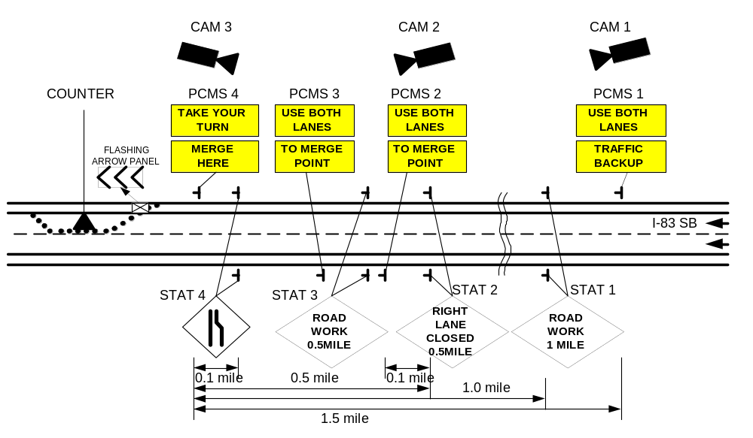
FIGURE 1 Configuration of the DLM system and data collection.

(a) No-merge control (e.g., NDOR control)
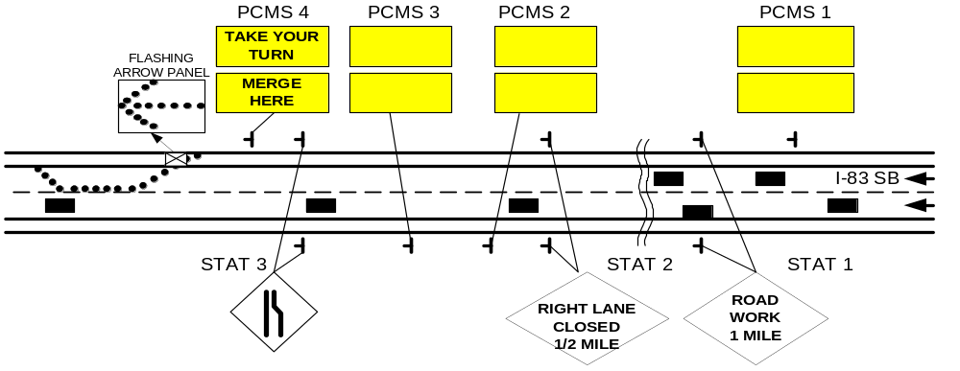
(b) DLM control (e.g., Static late merge control)
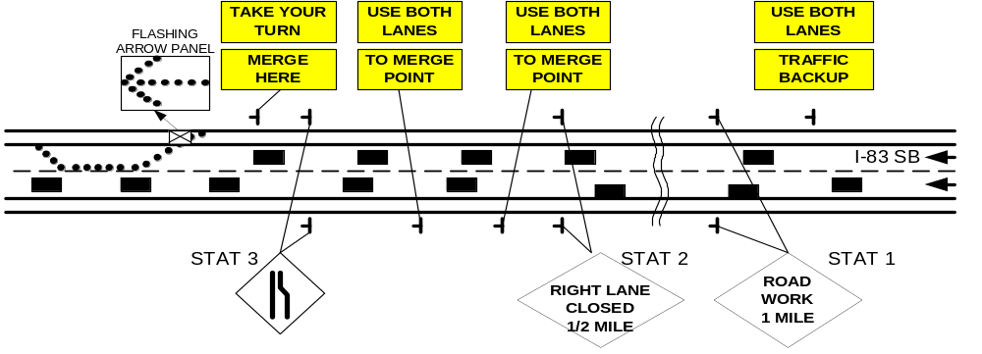
FIGURE 2 Traffic conditions and merging messages under the No-merge and DLM controls.

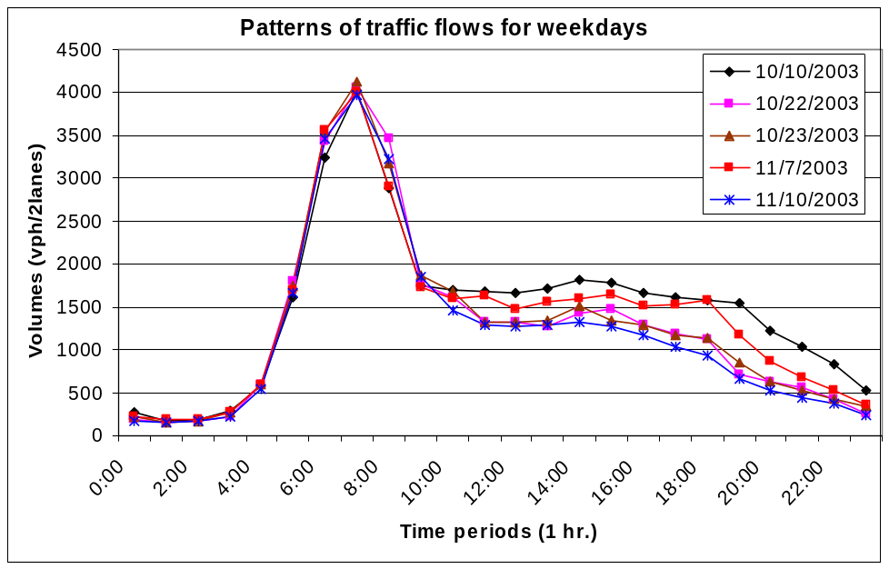
FIGURE 3 Patterns of the traffic flows during the data collection days.

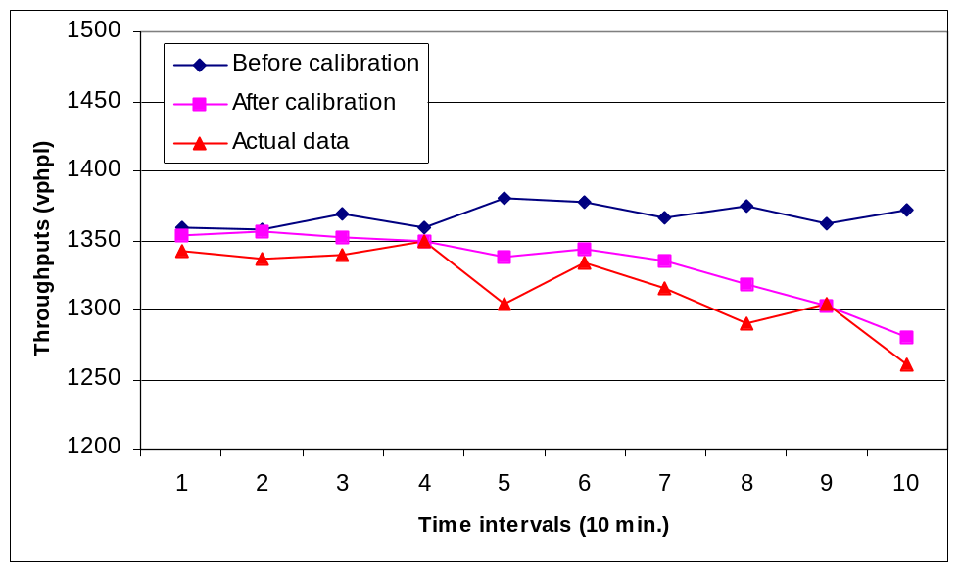
FIGURE 4 Comparison of the work zone throughputs
under the simulated work zone operations.
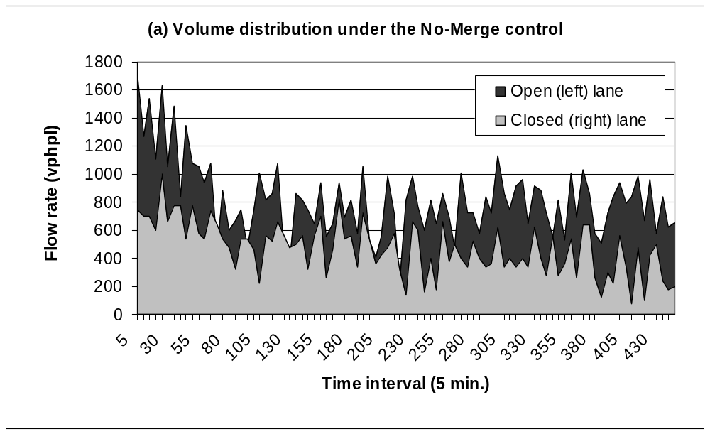
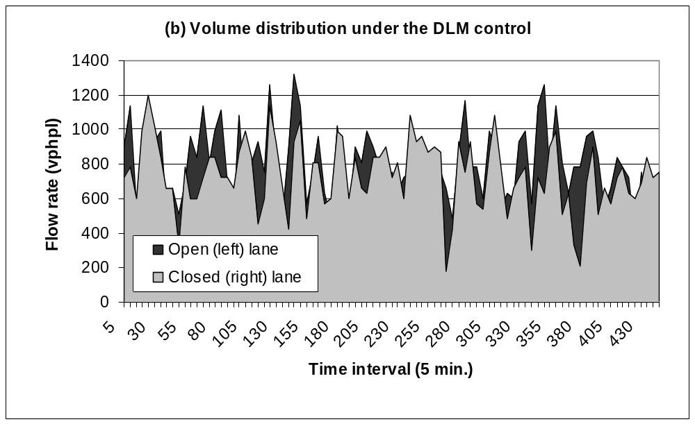
FIGURE 5 Volume distribution between the open (left) and closed (right) lanes
at the middle point under the No-merge (a) and DLM (b) controls.

(a) An example of the forced merge behavior
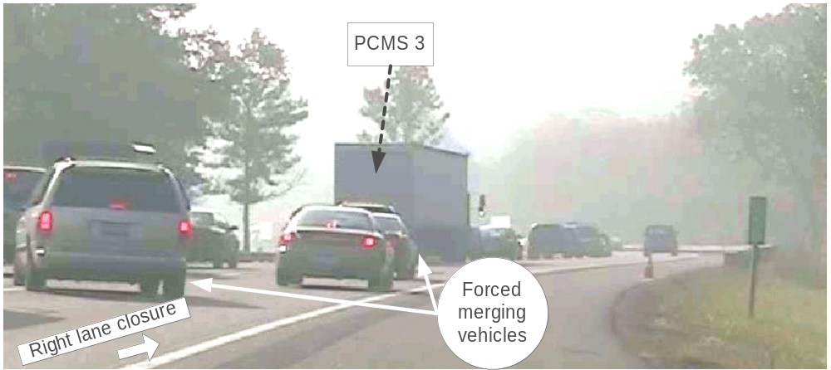

(b) An example of the lane straddling behavior
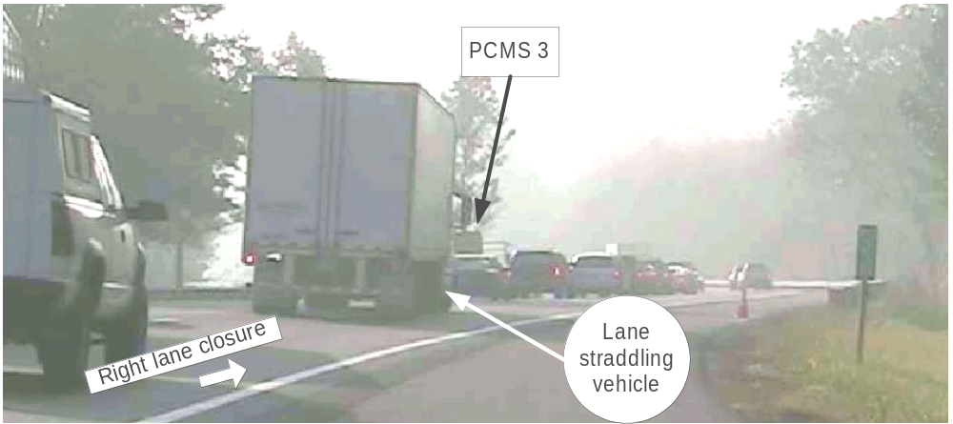

(c) An example of the lane blocking behavior
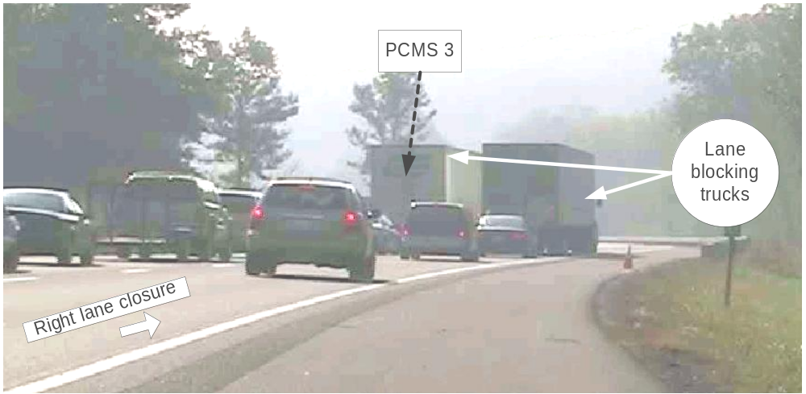
FIGURE 6 Examples of traffic merging conflicts around the middle point.

